Vote NO to the Treaty of Lisbon!

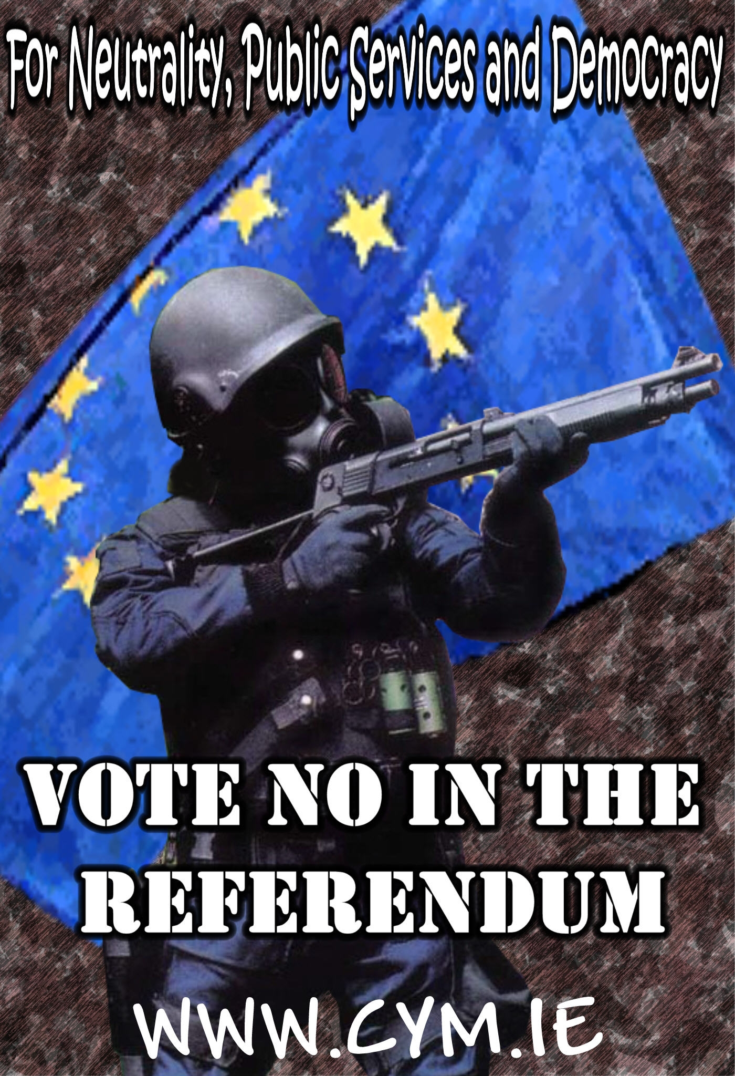

This summer the eyes of Europe will be on Ireland as only we have the opportunity to vote on the Lisbon Treaty. While the Dutch and French people have already rejected this treaty, it is now being forced on us again.

“Thankfully, they haven’t changed any of the substance”
Taoiseach Bertie Ahern, June 2007

For Democracy

This treaty increases the power and control of unelected EU elites and civil servants. It takes power away from our elected national governments and reduces our influence within the Union’s own structures.

“The Constitution is the capstone of a European federal state.”
Belgian Prime Minister Guy Verhofstadt, June 2004

For Sovereignty

The Constitution gives primacy to EU law and directives over domestic law. It also gives power to the European Court of Justice (ECJ) over national courts in interpreting laws and hearing cases. The EU’s interest will be to extend its powers and as the treaty is amendable once passed without need of a referendum, we are in fact handing a blank cheque over to unelected bureaucrats.

“Of course there will be transfers of sovereignty. But would it be intelligent to draw the attention of public opinion to this fact?”
Prime Minister of Luxembourg Jean-Claude Juncker, July 2007

For Public Services

The Lisbon Treaty is a blueprint for a privatised Europe. It makes into constitution laws that open our health, education, and transport services and our natural resources to privatisation and sale to multi-national corporations.

“A European framework law shall establish the measures in order to achieve the liberalisation of a specific service.”
Article III-147

For Workers Rights

The ECJ recently ruled that a Latvian company, Laval, operating in Sweden can legally pay the Latvian minimum wage. This ruling serves to greatly undermine terms and conditions won by workers in their own countries, furthers the erosion of workers rights and the race to the bottom in conditions, which will serve to increase racism and xenophobia. Voting for the treaty would increase the powers of the EU to erode workers rights.

“The ECJ’s ruling runs roughshod over trade union rights … The rulings are poorly reasoned and inconsistent.”
Lawyer Richard Arthur of Thompsons law firm, December 2007

For Neutrality

This treaty militarises the EU. Political and military elites will form a common defence and foreign policy with an army capable of ‘peace making missions’ far from European borders. While Irish neutrality is barely existent at present, it does not mean we should condemn young Irish soldiers to die far from home for EU interests.

"Battle Groups could be used to go to war. Why did the EU create the Battle Group? It is not just to help rebuild a country. The Battle Groups are not for building schools. We shouldn’t think the EU is for soft power and NATO for tough power."
Secretary General of NATO Jaap de Hoop Scheffer, March 2005

The Connolly Youth Movement asks all those who support democracy to reject this treaty and vote No in the referendum.

